Tute 5 Normal Distribution
Extension Activities

Question 1 More Difficult Practice
(a) A random variable (X) is normally distributed with a mean of 16 and standard deviation of 4. Answer the following questions:
- What proportional of observations is between 8 and 18?
- What is the minimum value of the top 1% of observations?
- What is value of x, if x is greater than 60% of all observations?

(b) It is given that a normal distribution has a standard deviation of 8, and 80% of the observations are greater than 15, what is the value of the mean?

Question 2 Parameters of normal model
Every normal model is defined by its mean (μ) and standard deviation (σ). For each model below, find the missing parameter.
- μ = 1200, 25% below 1000; σ = ?
- σ = 0.1, 90% above 0.2; μ = ?

Question 3 ASX
The number of shares traded daily is referred to as the volume of trade.During the 2007/08 financial year the average volume traded daily for the ASX All Ordinaries was 935 million with a standard deviation of 262 million. Assume that the number of All Ordinaries shares traded daily on the ASX is a normal random variable with a mean of 935 million and a standard deviation of 262 million. For a randomly selected day, what is the probability that the volume of trading in these shares is:
(a) below 500 million?
(b) between 750 and 1,000 million?
(c) below 1,500 million?
(d) above 1,200 million?
(e) On 18 September 2008 the All Ordinaries volume of trade was 2,125 million. What is the probability that the volume of trading for the All Ordinaries on a randomly selected day is at least 2,125 million? What conclusions can you draw from this probability?

Question 4 Coffee Machine
A drinks machine dispenses coffee into cups. A sign on the machine indicates that each cup contains 50ml of coffee. The machine actually dispenses a mean amount of 55ml per cup and 10% of the cups contain less than the amount stated on the sign.
(a) Assuming that the amount of coffee dispenses into each cup is normally distributed, find the standard deviation of the amount of coffee dispensed per cup in ml.
(b) Following complaints, the owners of the machine make adjustments. Only 2.5% of cups now contain less than 50ml. The standard deviation of the amount dispensed is reduced to 3ml, find the new mean amount of coffee per cup.

*Question 5 The lost hen
Hens usually start laying eggs when they are 6 months old. These young hens tend to lay smaller eggs, with average 51 grams and standard deviation 5.3 grams. When they reach the age of 1 year, the eggs they lay will average 67 grams with standard deviation 6.4 grams.

A chicken farmer has two sheds, one for 6 month old hens and the other for 1 year old hens. One day, a hen was lost and found a few days later in the nearby bush, with an egg lying underneath. The egg weighs 59 grams. The farmer wants to put her back to the shed where the hen came from. Which one should he choose? (Assume the weights of eggs are normally distributed.)
(Adapted from De Veaux and Velleman (2004) “Intro Stats”, Pearson)

Suggested Solutions
Question 1 More Difficult Practice
(a) Given μ = 16, σ = 4
(i) P(8 < X <18) = P(-2 < Z < 0.5) = 0.4772 + 0.1915 = 0.6687
(ii) It is an upper tail problem. Z score for α = 1% is 2.3263.
The min value = 16 + 4*2.3263 = 25.3052
(iii) Z score for α = 40% is 0.2533.
The min value = 16 + 4*0.2533 = 17.0132

(b) Z score for α = 20% = 0.8416
μ = 15 + 8*0.8416 = 21.7328

Question 2 Parameters of normal model
(a) 296.5159
(b) 0.32816

Question 3 ASX
The number of shares traded daily is referred to as the volume of trade.During the 2007/08 financial year the average volume traded daily for the ASX All Ordinaries was 935 million with a standard deviation of 262 million. Assume that the number of All Ordinaries shares traded daily on the ASX is a normal random variable with a mean of 935 million and a standard deviation of 262 million. For a randomly selected day, what is the probability that the volume of trading in these shares is:
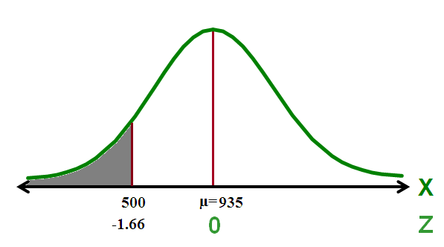
(a) below 500 million?
P(X < 500)
= P(Z < $\frac{500-935}{262}$ )
= P(Z < -1.66)
= 0.5 – 0.4515 = 0.0485

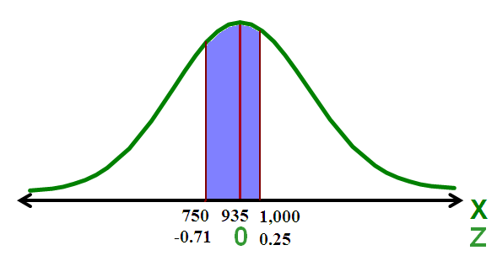
(b) between 750 and 1,000 million?
P(750< X< 1,000)
=P( $\frac{750-935}{262}$< Z< $\frac{1,000-935}{262}$)
= P(-0.71 < Z < 0.25)
= P(-0.71 < Z < 0 ) + P(0 < Z < 0.25)
= 0.2611 + 0.0987
= 0.3598
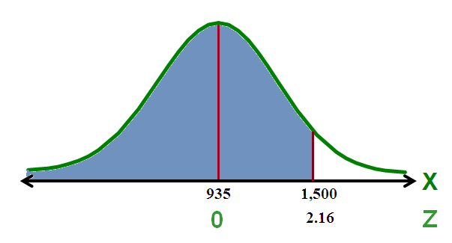
(c) below 1,500 million?
P(X < 1,500)
= P(Z < $\frac{1500-935}{262}$ )
= P(Z < 2.16)
= 0.5 + 0.4846
= 0.9846

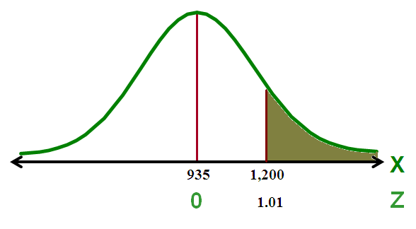
(d) above 1,200 million?
P(X > 1,200)
= P(Z > $\frac{1200-935}{262}$ )
= P(Z > 1.01)
= 0.5 - 0.3438
= 0.1562

(e) On 18 September 2008 the All Ordinaries volume of trade was 2,125 million. What is the probability that the volume of trading for the All Ordinaries on a randomly selected day is at least 2,125 million? What conclusions can you draw from this probability?
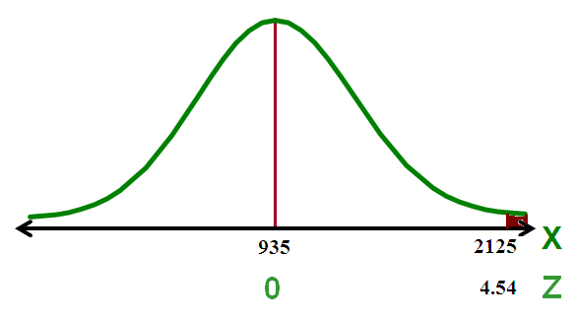
P(X > 2,125)
= P(Z > $\frac{2125-935}{262}$ )
= P(Z > 4.45)
= 0.5 - 0.499996602 (From Excel)
= 0.000003398
= 0 (approx.)

We can therefore conclude that such a day of trading is very rare.

Question 4 Coffee Machine
A drinks machine dispenses coffee into cups. A sign on the machine indicates that each cup contains 50ml of coffee. The machine actually dispenses a mean amount of 55ml per cup and 10% of the cups contain less than the amount stated on the sign. Assuming that the amount of coffee dispenses into each cup is normally distributed,
(a) find the standard deviation of the amount of coffee dispensed per cup in ml.

µ=55
10% of cups have a quantity of less than 50ml which means:
P(X < 50) = 0.10

Using the Inverse Normal table and the fact that the Normal distribution is symmetric, we find the z value corresponding to 50 is -1.2816
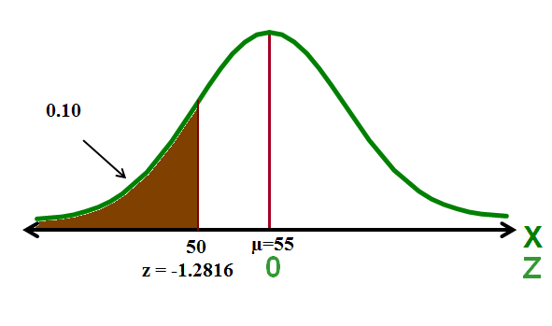
So: Z = $\frac{x-µ}{σ}$
-1.2816 = $\frac{50-55}{σ}$
σ $×$ (-1.2816) = -5

σ = $\frac{-5}{-1.2816}$
σ = 3.90137
σ = 3.90 (correct to 3 significant figures)

Following complaints, the owners of the machine make adjustments. Only 2.5% of cups now contain less than 50ml. The standard deviation of the amount dispensed is reduced to 3ml,

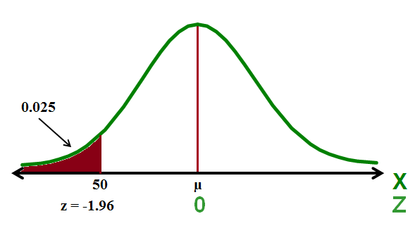
(b) find the new mean amount of coffee per cup.

Now after the adjustments: P(X < 50) = 0.025
Using the Inverse Normal table: z value is -1.96
So: Z = $\frac{x-µ}{σ}$
-1.96 = $\frac{50-µ}{3}$
3 $×$ (-1.96) = 50 - µ
µ - 5.88 = 50

Therefore µ = 50 + 5.88 = 55.88 ml

Question 5 The lost hen
Test 1: Is the egg laid by a 6 month old hen?
Ho: It is laid by a 6 month old hen.
H1: It is not laid by a 6 month old hen.

The p-value = P(Type 1 error) = P(Reject Ho when Ho is true.)
= P(an egg weighs 59 grams or more assuming that it is laid by a 6 month old hen)
= P[Z > (59-51)/5.3] = P(Z > 1.51) = 0.5 – 0.4345 = 6.55%

Test 2: Is the egg laid by 1 year month old hen?
Ho: It is laid by a 1 year old hen.
H1: It is not laid by a 1 year old hen.

The p-value = P(Type 1 error) = P(Reject Ho when Ho is true.)
P(an egg weighs 59 grams or less assuming it is laid by a 1 year old hen)
= P[Z < (59-67)/6.4] = P(Z < -1.25) = 0.5 – 0.3944 = 10.56%
Given the smaller Type 1 error for Test 1 than Test 2, we are more willing to reject Ho in Test 1.
Hence, there is a greater chance that it is laid by a 1 year old.

